Team Java Lounge

IS420: Database Application Development

Deliverable IV

December 5th, 2017

_______________________________________By: ________________________________________

Charles Douglas

Grayson King

Luvneet Singh

Jay Early

Josiah Tillett

University of Maryland, Baltimore County

College of Engineering and Information Systems

Jay Early {1, 2, 3, 13}

1.[*] Add a new hotel: Create a new hotel with appropriate information about the hotel as input parameters   
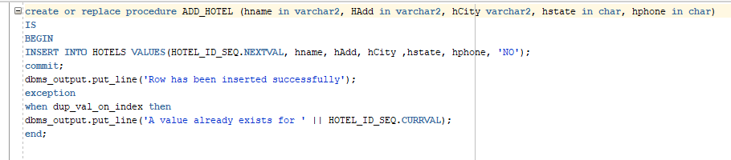



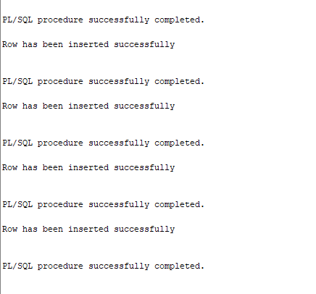

2. [*] Find a hotel: Provide as input the address of the hotel and return its hotel ID  
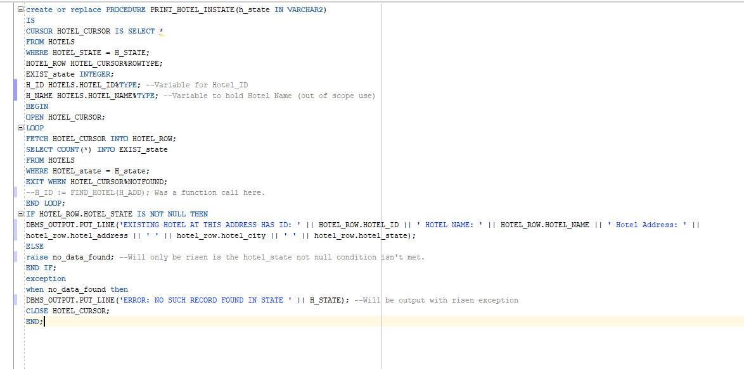

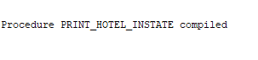  
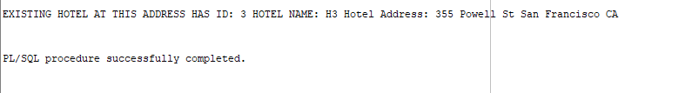

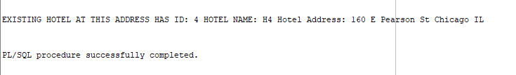

3. [*] Sell existing hotel: Sell a hotel by providing its hotel ID. Mark it as sold, do not delete the record.

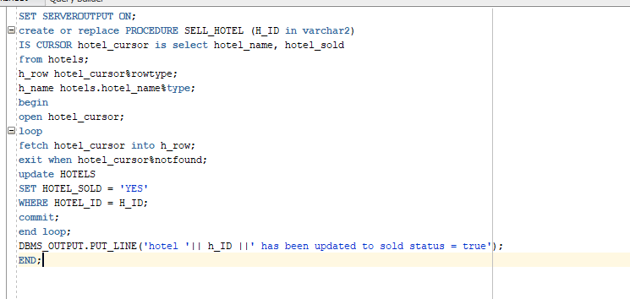

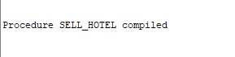

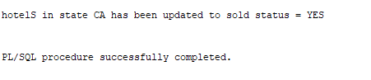

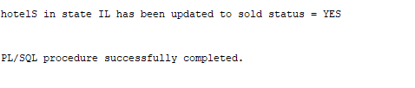



4. [**] Make a reservation: Input parameters: Hotel, guest’s name, start date, end dates,

room type, date of reservation, etc. Output: reservation ID (this is called confirmation

code in real-life ).

Added by Grayson

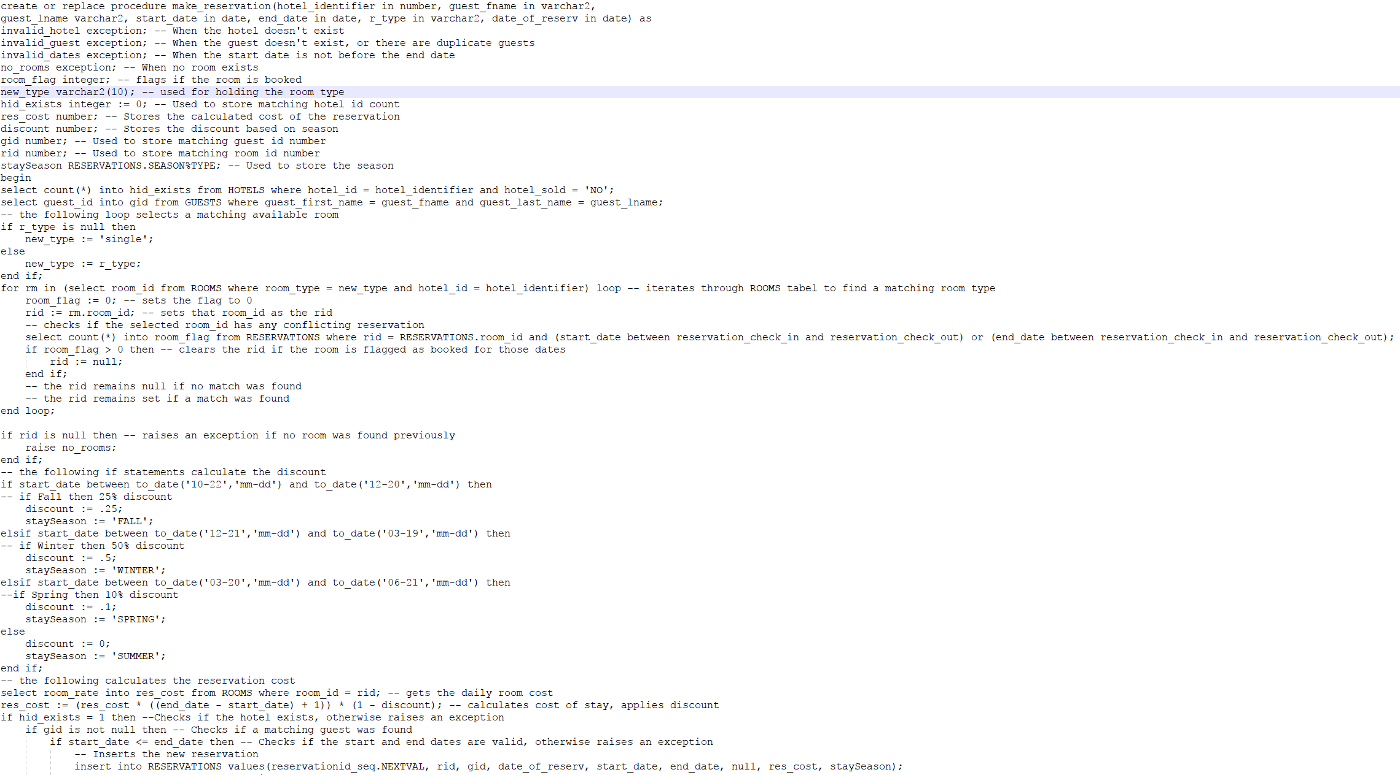

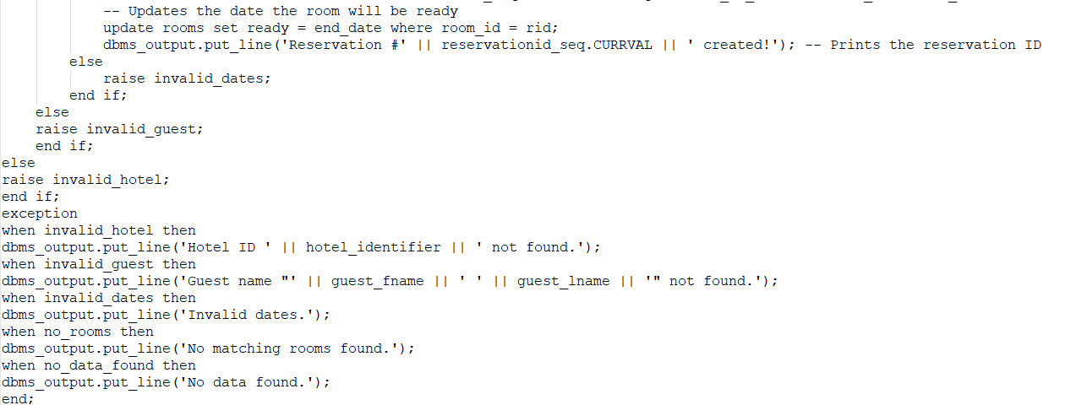



6. [*] Add a service to a reservation: Input: ReservationID, specific service. Add it to the reservation for a particular date. Multiple services are allowed on a reservation for the same date

Added by Grayson

.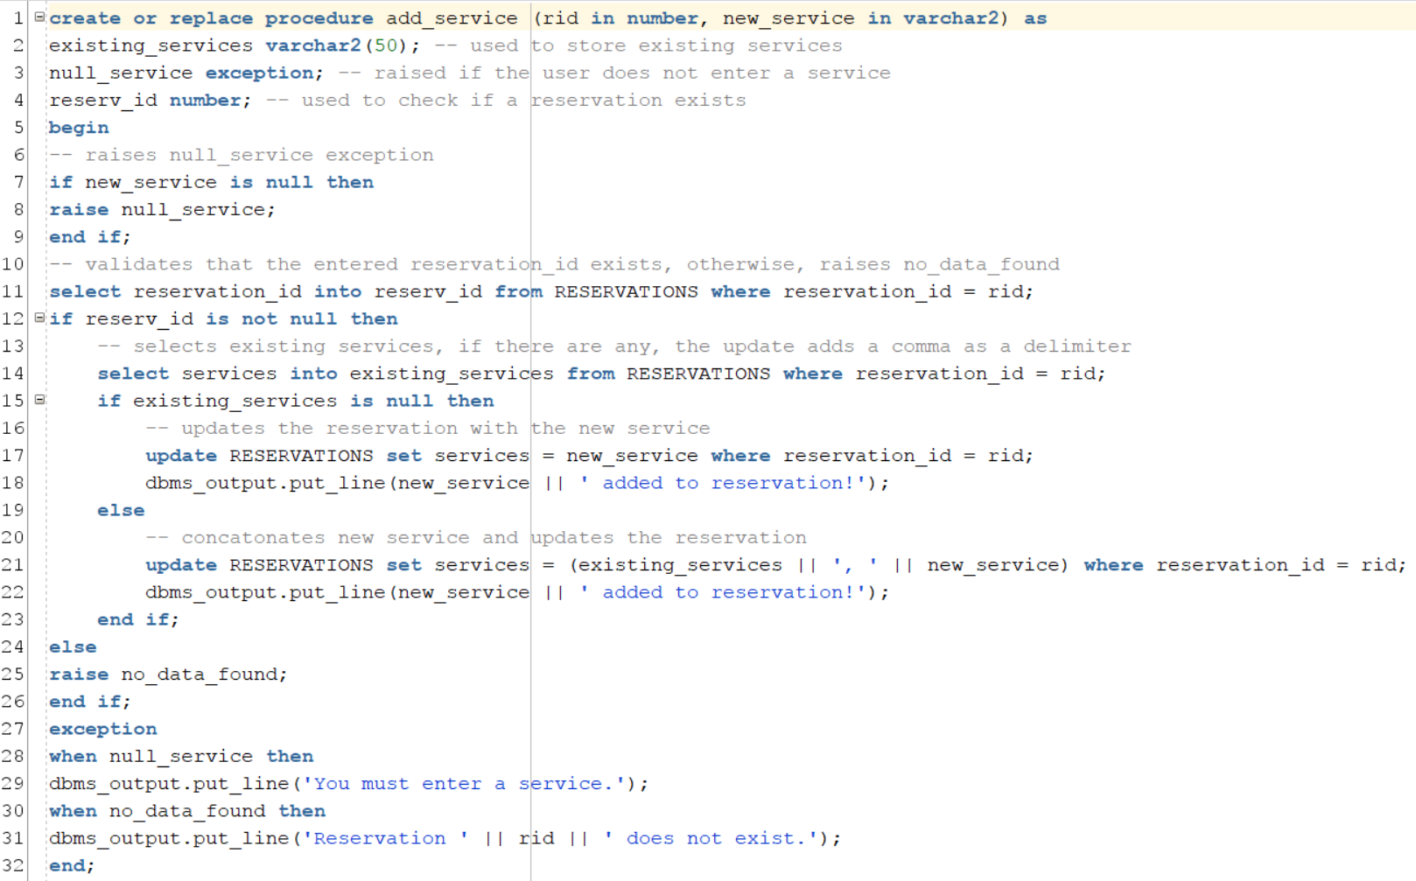



**7. FindReservation & PrintReservation Josiah (*)**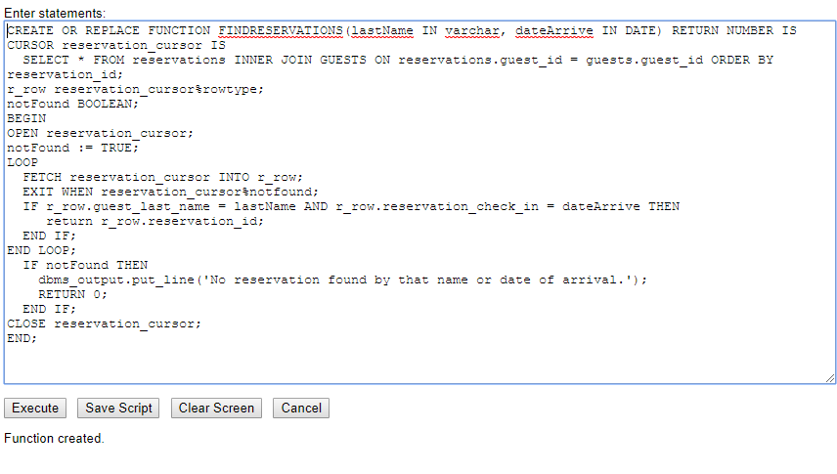

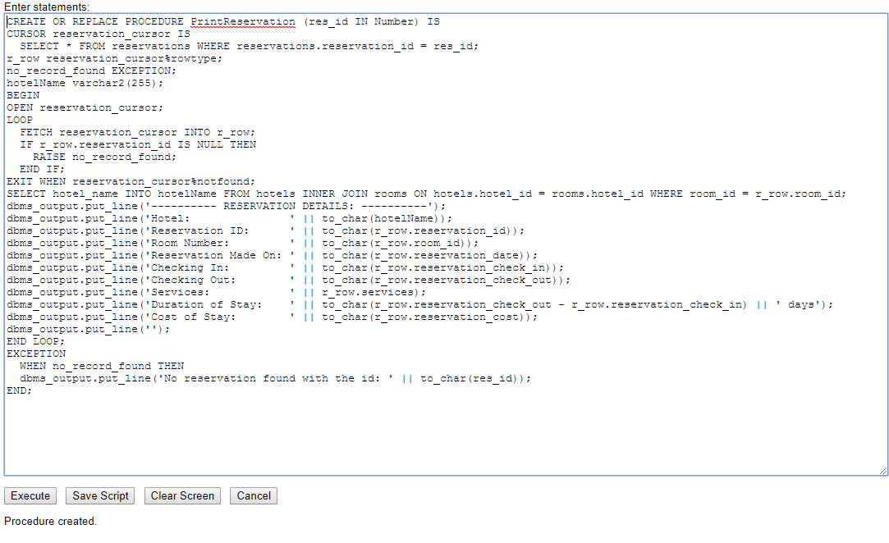

---------------------------

**8. CancelReservation Josiah (*)**

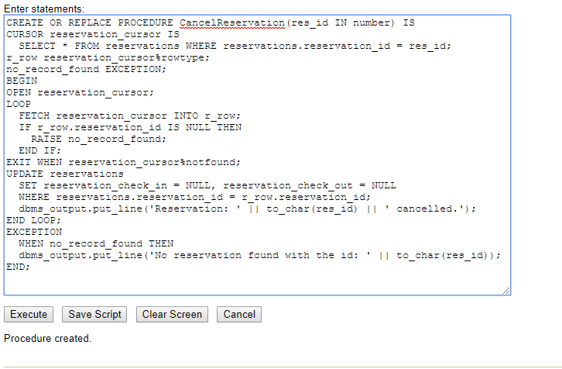

-------------------------------------------------

**9. ChangeReservation Josiah (**)**

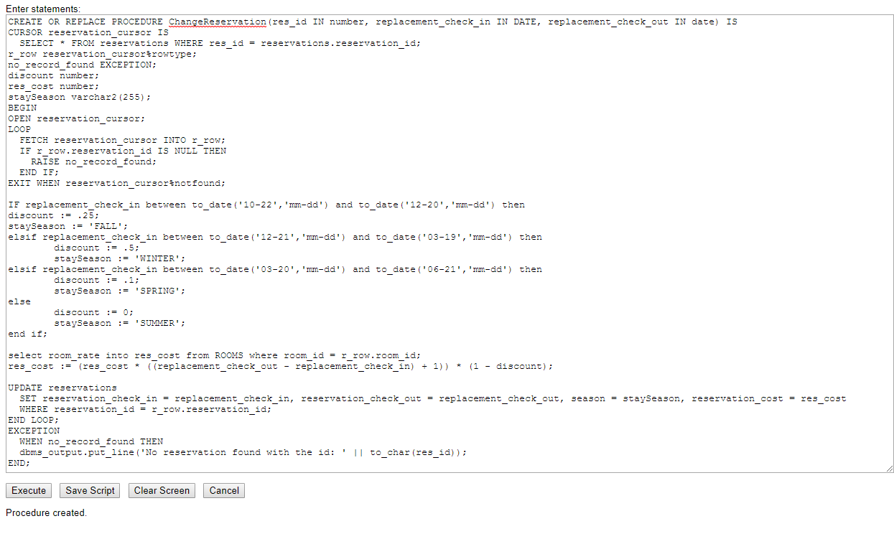

10. **Change_Room_Type -charles douglas

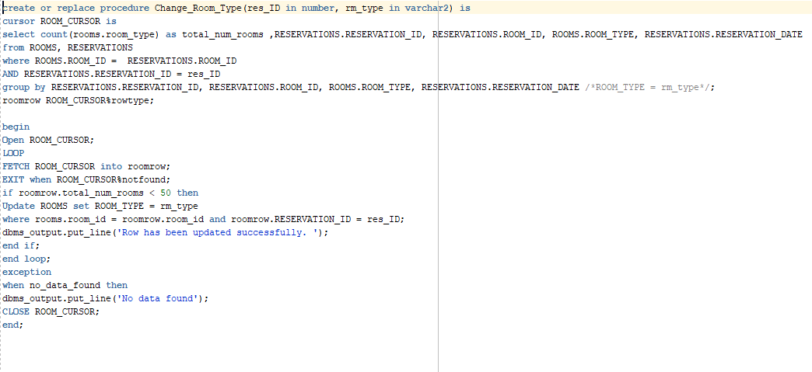



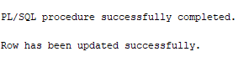

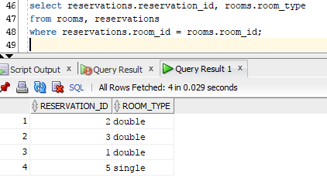

11. **Rooms_Available -Charles Douglas

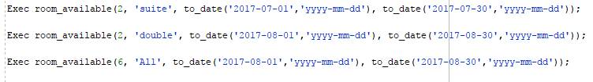

12. [*] AvailabilityOfRoomHotelPerInterval: Input a room type, hotel ID, date interval and return the number of available rooms during that time interval

create or replace Function GetAvailableRoom --function to get the number of rooms

(H_ID IN NUMBER, Start_Date IN DATE, End_Date IN DATE, r_type IN VARCHAR2) --assigns what form the values would be in

return number

IS num_rooms number;

BEGIN

select count(ROOMS.room_id) into num_rooms

from hotels, rooms, reservations

where hotels.hotel_id = rooms.hotel_id --joins hotels and rooms

and ROOMS.room_id = reservations.ROOM_ID --joins reservations and rooms

and hotels.hotel_id = h_id --sets hotels.hotel_id to h_id

AND ROOMS.ROOM_TYPE = r_type --sets rooms.room_type to r_type

and RESERVATIONS.RESERVATION_CHECK_IN NOT between start_date and end_date

and RESERVATIONS.RESERVATION_CHECK_OUT NOT BETWEEN start_date and end_date; --makes sure check in and check out aren’t between their dates

RETURN NUM_ROOMS;

END;

declare --uses the number of rooms to see which rooms are available

total_num number;

begin

total_num := GetAvailableRoom(1,to_date('2017-10-30','YYYY-MM-DD'), to_date('2018-12-31', 'YYYY-MM-DD'),'economy');

dbms_output.put_line('Rooms of this type available ' || total_num);

end;

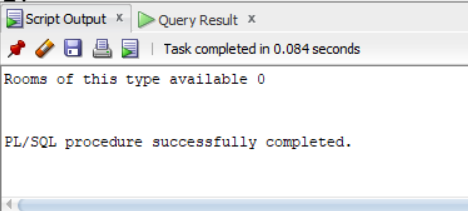

13. [***] RoomCheckoutReceipt: Input: ReservationID Output:

* 1. Guest name
  2. Room number, rate per day and possibly multiple rooms (if someone reserved several rooms)
  3. Services rendered per date, type, and amount
  4. Discounts applied (if any)
  5. Total amount to be paid   
       
     create or replace procedure Room_Checkout_Reciept(resID in number) IS  
     cursor reciept_cursor is select HOTELS.HOTEL_ID HOTEL_ID,  
     HOTELS.HOTEL_NAME HOTEL_NAME,  
     HOTELS.HOTEL_ADDRESS HOTEL_ADDRESS,  
     HOTELS.HOTEL_CITY HOTEL_CITY,  
     HOTELS.HOTEL_STATE HOTEL_STATE,  
     HOTELS.HOTEL_PHONE HOTEL_PHONE,  
     HOTELS.HOTEL_SOLD HOTEL_SOLD,  
     GUESTS.GUEST_ID GUEST_ID,  
     GUESTS.GUEST_FIRST_NAME,  
     GUESTS.GUEST_LAST_NAME,  
     GUESTS.GUEST_ADDRESS,  
     GUESTS.GUEST_CITY,  
     GUESTS.GUEST_STATE,  
     ROOMS.ROOM_ID ROOM_ID,  
     ROOMS.HOTEL_ID HOTEL_ID_0,  
     ROOMS.ROOM_CAPACITY ROOM_CAPACITY,  
     ROOMS.ROOM_RATE ROOM_RATE,  
     ROOMS.READY READY,  
     ROOMS.CLEANED CLEANED,  
     ROOMS.SMOKING SMOKING,  
     ROOMS.ROOM_TYPE ROOM_TYPE,  
     RESERVATIONS.RESERVATION_ID RESERVATION_ID,  
     RESERVATIONS.ROOM_ID ROOM_ID_1,  
     RESERVATIONS.RESERVATION_DATE RESERVATION_DATE,  
     RESERVATIONS.RESERVATION_CHECK_IN RESERVATION_CHECK_IN,  
     RESERVATIONS.RESERVATION_CHECK_OUT RESERVATION_CHECK_OUT,  
     RESERVATIONS.SERVICES SERVICES,  
     RESERVATIONS.SEASON,  
     TRANSACTIONS.TRANSACTION_ID TRANSACTION_ID,  
     TRANSACTIONS.GUEST_ID GUEST_ID_2,  
     TRANSACTIONS.RESERVATION_ID RESERVATION_ID_3,  
     TRANSACTIONS.CREDIT_CARD CREDIT_CARD,  
     TRANSACTIONS.TRANSACTION_TOTAL TRANSACTION_TOTAL,  
     TRANSACTIONS.TRANSACTION_DATE TRANSACTION_DATE,  
     SERVICES.SERVICE_NAME, SERVICES.SERVICE_COST  
     from HOTELS, GUESTS, ROOMS, RESERVATIONS, TRANSACTIONS, SERVICES  
     where HOTELS.HOTEL_ID = ROOMS.HOTEL_ID  
     and ROOMS.ROOM_ID = RESERVATIONS.ROOM_ID  
     AND RESERVATIONS.RESERVATION_ID = TRANSACTIONS.RESERVATION_ID  
     and guests.guest_id = reservations.guest_id  
     and RESERVATIONS.RESERVATION_ID = resID  
     and RESERVATIONS.SERVICES = services.service_name;  
      -- Denotes argument passed in  
     reciept_row reciept_cursor%rowtype;  
     totalAmount number := 0;  
     --services varchar2(50);  
     lengthOfStay number;  
     totalServiceCost number;  
     totalROOM number;  
     discountRate number := 0;  
     discountAmount number:= 0;  
     numRooms number := 1; --Number of Rooms booked (will be changed later)  
     servName SERVICES.SERVICE_NAME%type;  
     servCost SERVICES.SERVICE_COST%type;  
     BEGIN  
     open reciept_cursor;  
     loop  
     fetch reciept_cursor into reciept_row;  
     EXIT when reciept_cursor%NOTFOUND;  
     lengthOfStay := reciept_row.RESERVATION_CHECK_OUT - reciept_row.RESERVATION_CHECK_IN;  
     totalROOM := reciept_row.ROOM_RATE * lengthOfStay;  
     totalServiceCost := reciept_row.service_cost * lengthOfStay;  
     totalAmount := totalROOM + totalServiceCost - discountAmount;  
     IF reciept_row.SEASON = 'WINTER' THEN -- When season is winter then applicable discount is applied  
     discountRate := .50;  
     discountAmount := discountRate * totalROOM;  
     end if;  
      if reciept_row.season = 'SPRING' then --If Spring time then applicable discount is taken into account.  
      discountRate := .10;  
      totalROOM := totalROOM - (discountRate * totalROOM);  
      end if;  
      if reciept_row.season = 'SUMMER' then --If Spring time then applicable discount is taken into account.  
      discountRate := .0;  
      totalROOM := totalROOM - (discountRate * totalROOM);  
      end if;  
     discountAmount := totalROOM * discountRate;  
       
     END LOOP;  
     if reciept_row.transaction_id is null then  
     raise no_data_found;  
     else  
     dbms_output.put_line('-------------------------- ' || reciept_row.HOTEL_NAME || ' -----------------------------');  
     dbms_output.put_line(' Guest Reciept ');  
     dbms_output.put_line('Transaction # ' || reciept_row.transaction_ID);  
     dbms_output.put_line('Guest Name: ' || reciept_row.GUEST_FIRST_NAME || ' ' || reciept_row.GUEST_LAST_NAME);  
     dbms_output.put_line('ROOM #' || reciept_row.ROOM_ID);  
     dbms_output.put_line('Rooms Booked: ' || numRooms);  
     dbms_output.put_line('Daily Rate: $' || reciept_row.ROOM_RATE);  
     dbms_output.put_line('Duration of stay: ' || lengthofStay || ' nights ');  
     dbms_output.put_line('Services booked: ' || reciept_row.service_name);  
     dbms_output.put_line('Service Charge p/day: $' || reciept_row.service_cost);  
     dbms_output.put_line('Room Charge: $'|| totalROOM);  
     dbms_output.put_line('Total Services Charge: $'|| totalServiceCost);  
     dbms_output.put_line('---------------------------------------------------------------------');  
     dbms_output.put_line('Applied Season Discounts: -' || discountAmount || ' (' || reciept_row.season || ') ');  
     dbms_output.put_line('---------------------------------------------------------------------');  
     dbms_output.put_line('Total Amount Due: $'|| totalAmount);  
     dbms_output.put_line('CREDIT - Payment Applied: (' || totalAmount || ') ');  
     dbms_output.put_line('CREDIT CARD XXXX' || reciept_row.credit_card);  
     dbms_output.put_line('----------------------------------------------------------------------');  
     dbms_output.put_line('NET Outstanding Balance: $0.00');  
     dbms_output.put_line('______________________________________________________________________');  
     end if;  
     exception  
     when no_data_found then  
     dbms_output.put_line('No data found for this reservation #');  
     close reciept_cursor;  
     END;

14. * Sold_hotels: Print all sold hotel information. Show ID, location, etc.

create or replace PROCEDURE Sold_Hotel_Information IS

CURSOR HOTEL_CURSOR IS --gets values into a cursor

SELECT *

FROM HOTELS

WHERE HOTEL_SOLD = 'YES'; --looks for hotels that are sold

HOTEL_ROW HOTEL_CURSOR%ROWTYPE;

BEGIN

OPEN HOTEL_CURSOR;

LOOP --loops through hotel_cursor

FETCH HOTEL_CURSOR INTO HOTEL_ROW; --uses the cursor to look through hotel_row

EXIT WHEN HOTEL_CURSOR%NOTFOUND; --exits cursor when no values are found

END LOOP;

DBMS_OUTPUT.PUT_LINE(HOTEL_ROW.HOTEL_ID || '' || HOTEL_ROW.HOTEL_NAME || '' || HOTEL_ROW.HOTEL_ADDRESS ||''|| HOTEL_ROW.HOTEL_PHONE); --outputs the hotel in order

close HOTEL_CURSOR; --closes the cursor

EXCEPTION --raises an exception for when there is no data found

WHEN no_data_found THEN

DBMS_OUTPUT.PUT_LINE('Error: Could not locate any Sold Hotels'); --outputs an error if any sold hotels were not found

END;

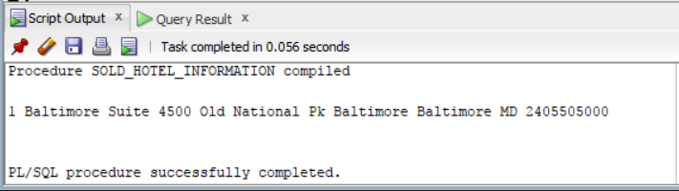

15. *Show_Cancelations -charles douglas

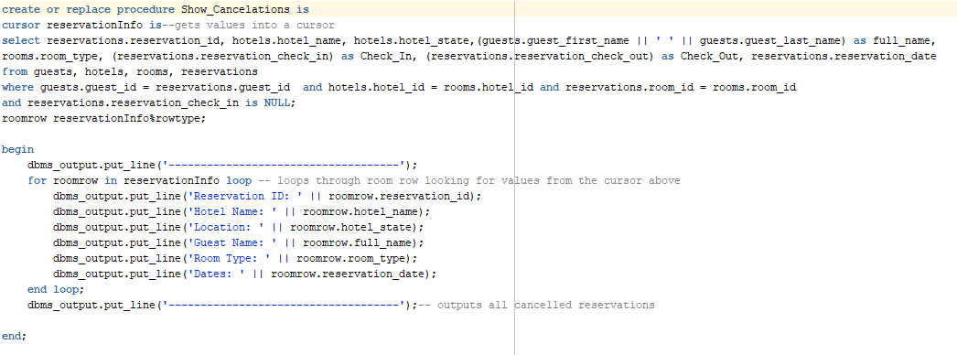



16. [**] SpecificHotelReport:

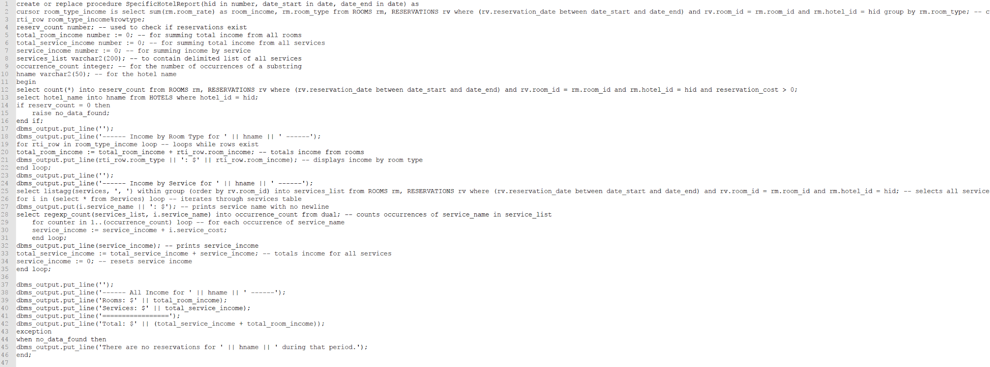

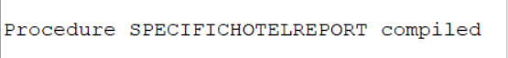

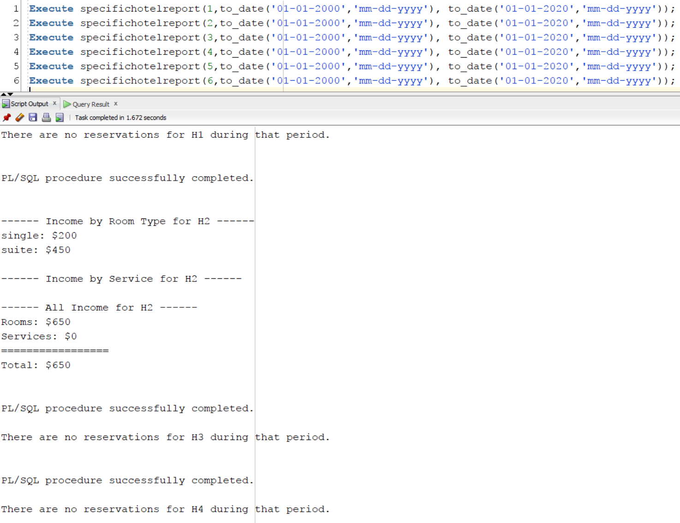

**17. TotalClariottMonthlyReport (**) Josiah**

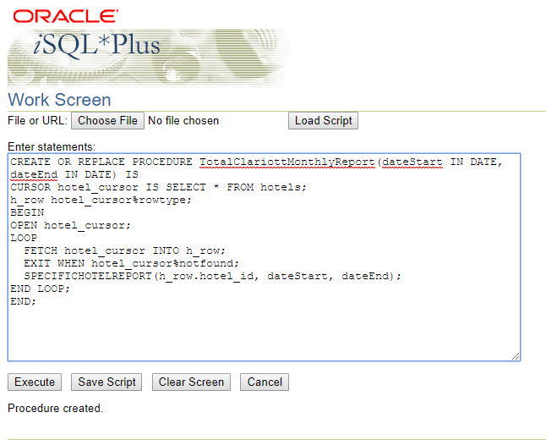

18. [**] TotalClariottStateReport: Input is state. Print total income from all sources of all hotels by room type and service type in the given state. Include discounts.

Added by Grayson King

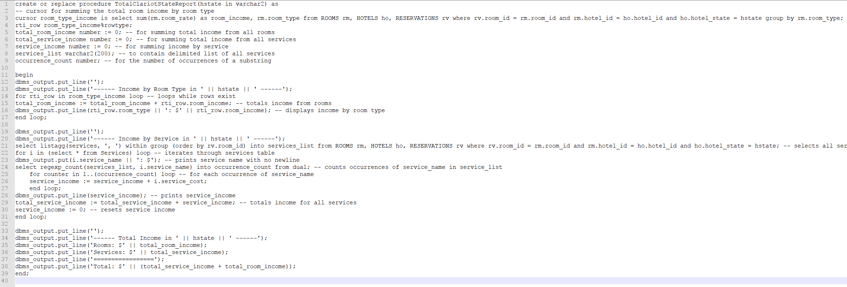



Scenario for testing the various operations and reports. Create a text file that makes the

appropriate calls to the PL/SQL stored procedures and functions that are created for the Hotel

Management System. This text file will be used to demonstrate how your software operates.

The list of actions below need to be translated into calls to your existing PL/SQL stored

procedures and functions. Each line identifies the minimum parameters to be entered in the call,

if your code requires additional parameters, feel free to supply.

1. Add a hotel: Added by Jay

a. Add a new hotel called H1 in New York, NY  
 exec add_hotel('H1', '500 5th ave', 'New York', 'NY', '9174302828');

b. Add a new hotel called H2 in Baltimore, MD  
 exec add_hotel('H2', '200 E Pratt St', 'Baltimore', 'MD', '4102271422');

c. Add a new hotel called H3 in San Francisco, CA  
 exec add_hotel('H3', '355 Powell St', 'San Francisco', 'CA', '4154271400');

d. Add a new hotel called H4 in Chicago, IL  
 exec add_hotel('H4', '160 E Pearson St', 'Chicago', 'IL', '3127871440');

e. Add a new hotel called HH1 in New York, NY  
 exec add_hotel('HH1', '1050 Park Ave', 'New York', 'NY', '3472123250');

f. Add a new hotel called HH2 in Baltimore, MD

exec add_hotel('HH2', '301 Light st', 'Baltimore', 'MD', '4103042200');

2. Find a hotel: Added by Jay

a. Find the hotel you entered in CA

exec PRINT_HOTEL_INSTATE('CA');

b. Find the first hotel you entered in NY

exec PRINT_HOTEL_INSTATE('NY');

3. Sell the hotels in CA and IL: Added by Jay  
exec SELL_HOTEL_BYSTATE('CA');

exec SELL_HOTEL_BYSTATE('IL');

4. Reservations: Added by Grayson

a. Make a reservation at hotel H2 by John Smith from Aug 1 – Aug 10 for a suite

Execute make_reservation(2, 'John', 'Smith', to_date('08-01-2017','mm-dd-yyyy'), to_date('08-10-2017','mm-dd-yyyy'), 'suite', sysdate);

b. Make a reservation at hotel H3 (already sold)

Execute make_reservation(3, 'John', 'Smith', to_date('08-01-2017','mm-dd-yyyy'), to_date('08-10-2017','mm-dd-yyyy'), null, sysdate);

c. Make a reservation at hotel H2 by John Smith from Feb 1 – Feb 10 for a single

Room

Execute make_reservation(2, 'John', 'Smith', to_date('02-01-2017','mm-dd-yyyy'), to_date('02-10-2017','mm-dd-yyyy'), 'single', sysdate);

d. Make a reservation at hotel HH2 by Nina Chase from Aug 1 – Aug 10 for a

double room

Execute make_reservation(6, 'Nina', 'Chase', to_date('08-01-2017','mm-dd-yyyy'), to_date('08-10-2017','mm-dd-yyyy'), 'double', sysdate);

e. Make a reservation at hotel H4 by Pierce Borg from Feb 1 – Feb 10 for a suite

Execute make_reservation(4, 'Pierce', 'Borg', to_date('02-01-2017','mm-dd-yyyy'), to_date('02-10-2017','mm-dd-yyyy'), 'suite', sysdate);

f. Make a reservation at hotel H4 by Pierce Borg from Mar 1 – Mar 10 for a suite

Execute make_reservation(4, 'Pierce', 'Borg', to_date('03-01-2017','mm-dd-yyyy'), to_date('03-10-2017','mm-dd-yyyy'), 'suite', sysdate);

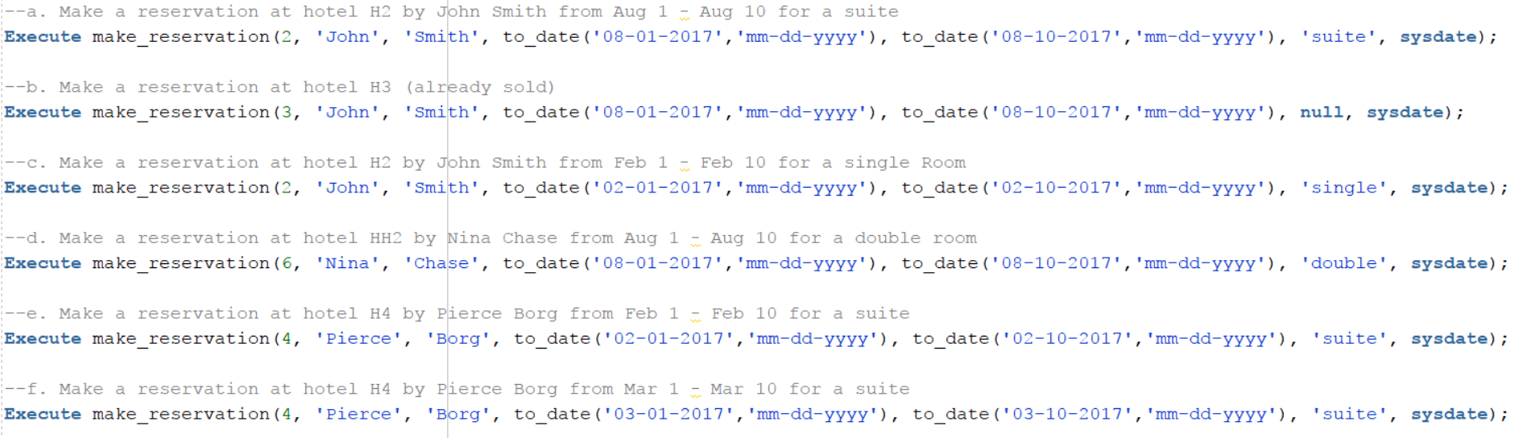

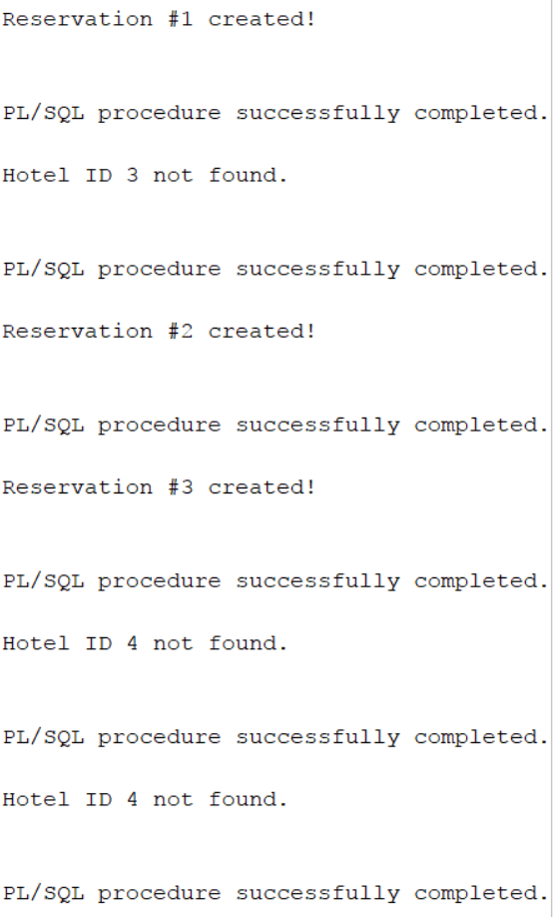

5. Find reservations described above in items 4a, 4c, 4e Josiah

1. dbms_output.put_line(to_char(FINDRESERVATIONS('Smith',to_date('08-01-2017','mm-dd-yyyy'))));

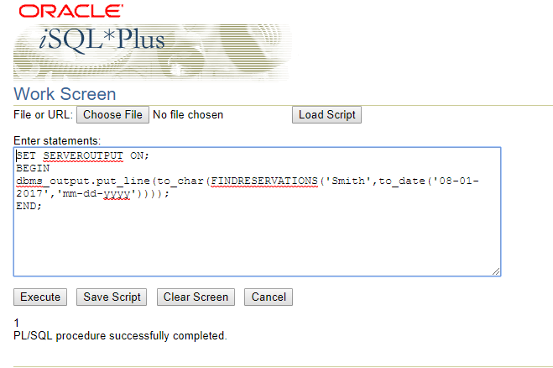

1. dbms_output.put_line(to_char(FINDRESERVATIONS('Smith',to_date('02-01-2017','mm-dd-yyyy'))));

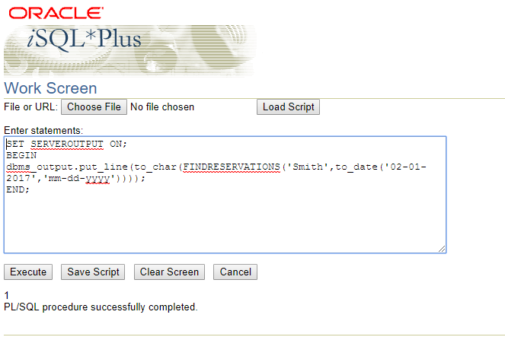

1. dbms_output.put_line(to_char(FINDRESERVATIONS('Borg',to_date('03-01-2017','mm-dd-yyyy'))));

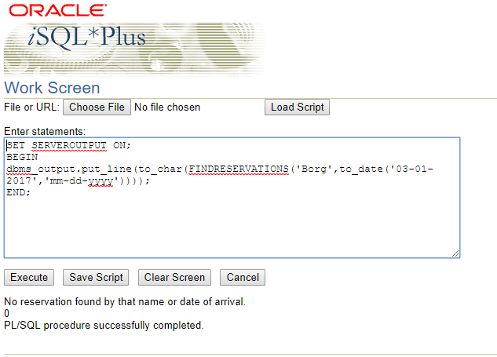

6. Show reservation details for reservations 4a, 4c, and 4e Josiah

1. PRINTRESERVATION(1);

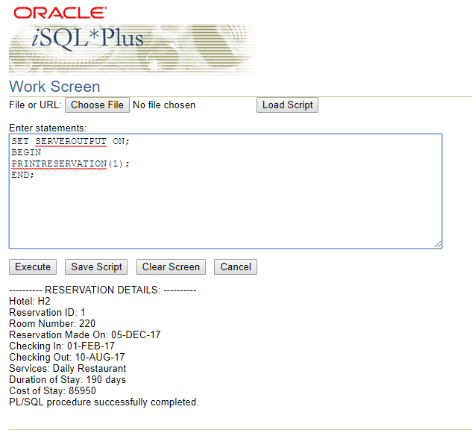

1. PRINTRESERVATION(2);

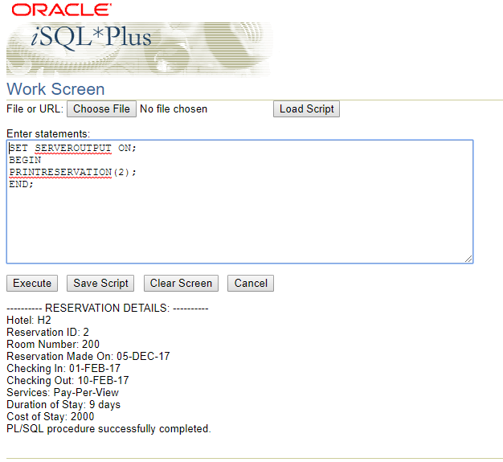

1. PRINTRESERVATION(0);

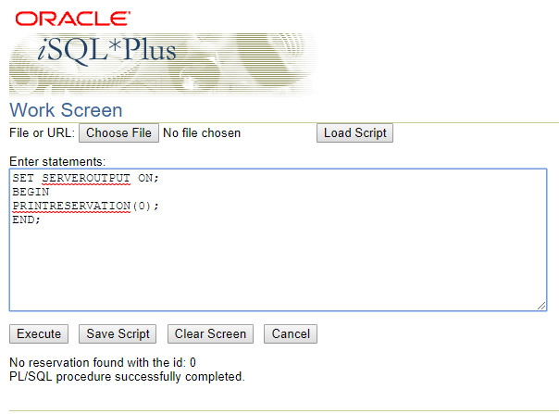

7. Change the following reservation dates: Josiah

a. For reservation 4a make the new dates from Aug 20-Aug 25

CHANGERESERVATION(1,to_date('08-20-17','MM-DD-YY'),to_date('08-25-17','MM-DD-YY'));

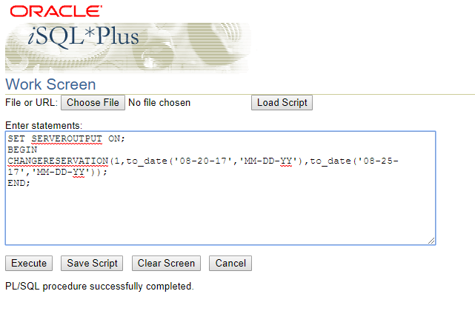

b. For reservation 4c make the new dates from Sept 20- Sept 25

CHANGERESERVATION(2,to_date('09-20-17','MM-DD-YY'),to_date('09-25-17','MM-DD-YY'));

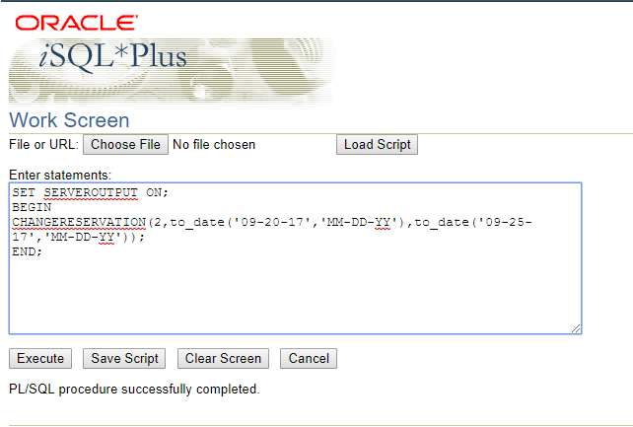

8. Show reservation details for reservations 4a, 4c, and 4e Josiah

1. PRINTRESERVATION(1);

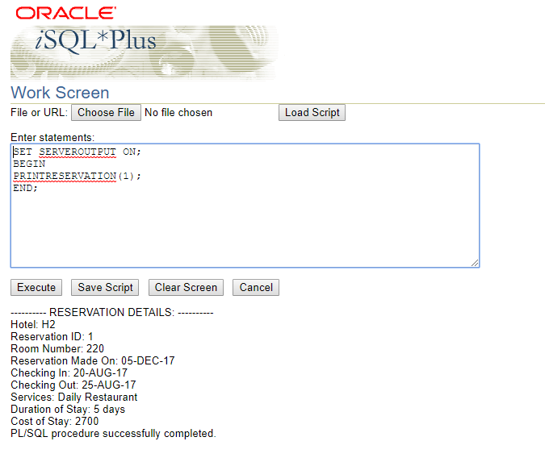

1. PRINTRESERVATION(2);

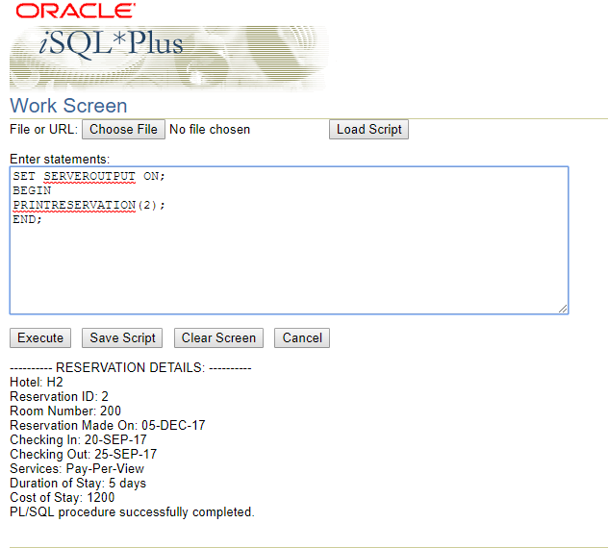

1. PRINTRESERVATION(0);



9. Cancel reservation 4d Josiah

CANCELRESERVATION(3);

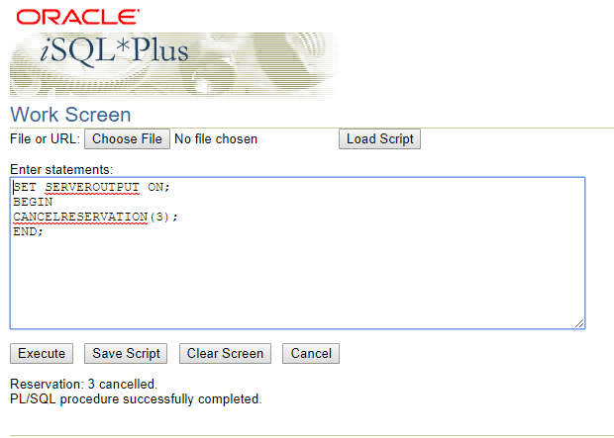

10. Cancel reservation 4f Josiah

CANCELRESERVATION(0);

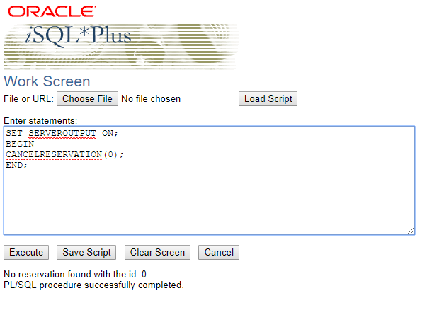

11. Add services: Added by Grayson

a. For reservation 4a add restaurant services for each day

Execute add_service(1, 'Daily Restaurant');

b. For reservation 4c add 1 pay-per- view movie for the first day

Execute add_service(3, 'Pay-Per-View');

c. For reservation 4e add laundry service for one day (of your choice)

Execute add_service(5, 'Laundry');

Commit;

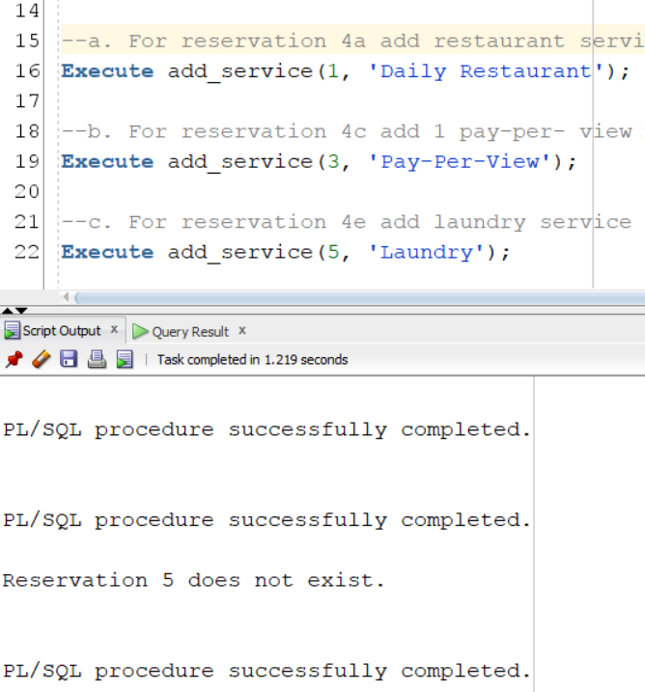

12. Show reservation details for reservations 4a, 4c, and 4e Josiah

1. PRINTRESERVATION(1);



1. PRINTRESERVATION(2);



1. PRINTRESERVATION(0);



13. Change reservation room type: Added by Charles

a. For reservation 4a from Suite to double

Exec Change_Room_Type(1,'double');

b. For reservation 4c from single to double

Exec Change_Room_Type(2,'double');

14. Show reservation details for reservations 4a, 4c Josiah

1. PRINTRESERVATION(1);



1. PRINTRESERVATION(2);



15. Show available suite rooms in H2 from Jul 1- Jul 30

Exec room_available(2, 'suite', to_date('2017-07-01','yyyy-mm-dd'), to_date('2017-07-30','yyyy-mm-dd'));



16. Show available double rooms in H2 from Aug 1- Aug 30

Exec room_available(2, 'double', to_date('2017-08-01','yyyy-mm-dd'), to_date('2017-08-30','yyyy-mm-dd'));

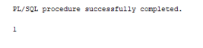

17. Show available rooms in H2 from Aug 1-Aug 30

Exec room_available(2, 'All', to_date('2017-08-01','yyyy-mm-dd'), to_date('2017-08-30','yyyy-mm-dd'));

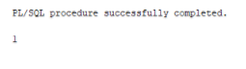

18. Room checkout receipt for John Smith for reservation in 4a Added by Jay

exec room_checkout_reciept(1);

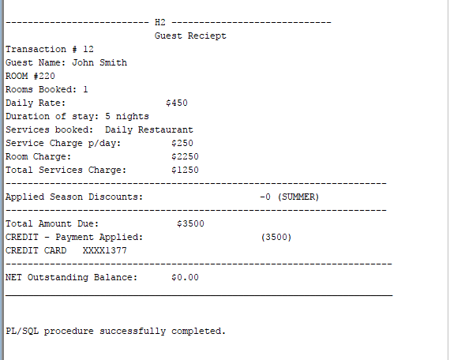

19. Room checkout receipt for John Smith for reservation in 4c Added by Jay

exec room_checkout_reciept(2);

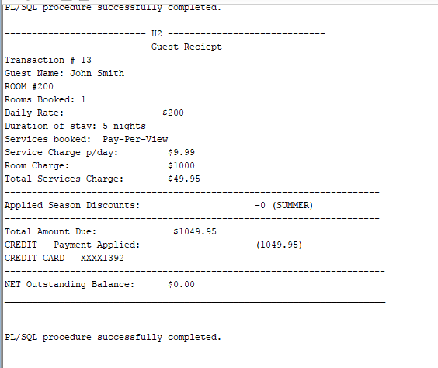

20. Room checkout receipt for Pierce Borg for reservation in 4e Added by Jay  
exec room_checkout_reciept(4); --canceled

21. Show sold hotels Added by Luvneet

Exec Sold_Hotel_Information;

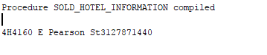

22. Show all cancellations Added by Charles

exec Show_Cancelations;

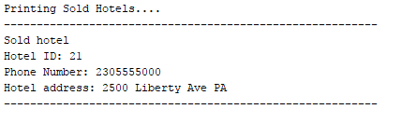

23. Specific hotel report: Run it for each hotel you have created Added by Grayson

Execute specifichotelreport(1,to_date('01-01-2000','mm-dd-yyyy'), to_date('01-01-2020','mm-dd-yyyy'));

Execute specifichotelreport(2,to_date('01-01-2000','mm-dd-yyyy'), to_date('01-01-2020','mm-dd-yyyy'));

Execute specifichotelreport(3,to_date('01-01-2000','mm-dd-yyyy'), to_date('01-01-2020','mm-dd-yyyy'));

Execute specifichotelreport(4,to_date('01-01-2000','mm-dd-yyyy'), to_date('01-01-2020','mm-dd-yyyy'));

Execute specifichotelreport(5,to_date('01-01-2000','mm-dd-yyyy'), to_date('01-01-2020','mm-dd-yyyy'));

Execute specifichotelreport(6,to_date('01-01-2000','mm-dd-yyyy'), to_date('01-01-2020','mm-dd-yyyy'));

24. TotalClariot Monthly: Run this report for the months of Feb, Aug, Jan, September Josiah

1. Exec TOTALCLARIOTTMONTHLYREPORT(to_date('02-01-2017','MM-DD-YYYY'),to_date('02-28-2017','MM-DD-YYYY'));

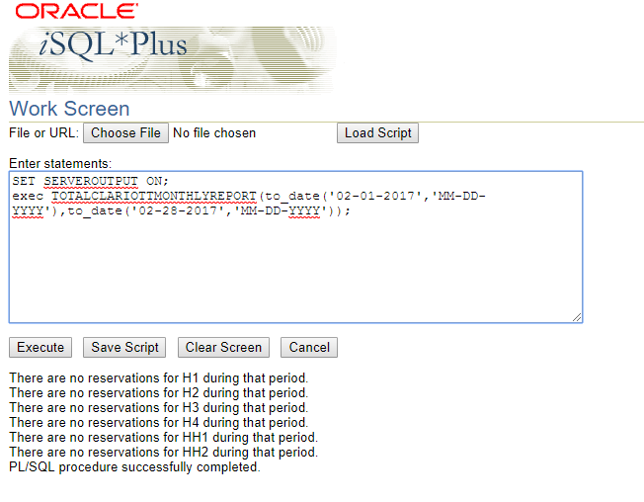

1. TOTALCLARIOTTMONTHLYREPORT(to_date('08-01-2017','MM-DD-YYYY'),to_date('08-31-2017','MM-DD-YYYY'));

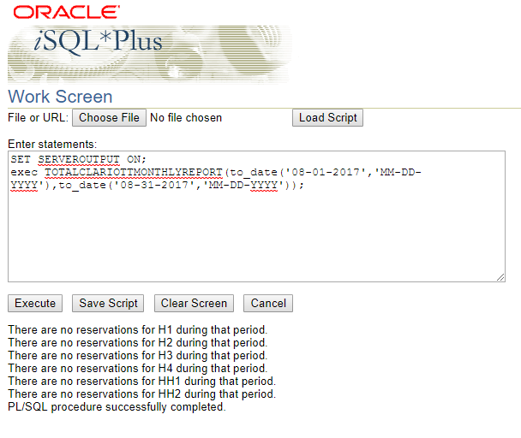

1. TOTALCLARIOTTMONTHLYREPORT(to_date('01-01-2017','MM-DD-YYYY'),to_date('01-31-2017','MM-DD-YYYY'));

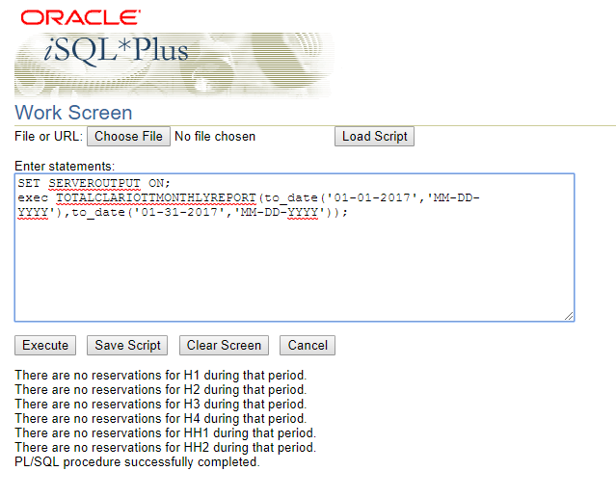

1. TOTALCLARIOTTMONTHLYREPORT(to_date('09-01-2017','MM-DD-YYYY'),to_date('09-30-2017','MM-DD-YYYY'));

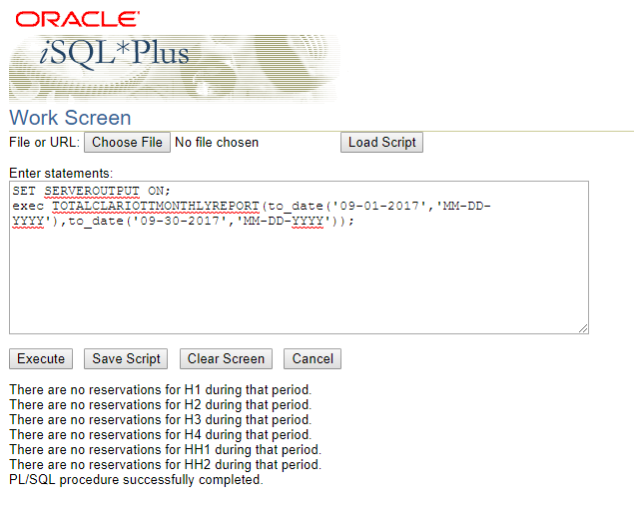

25. Total Clariot State report for NY, MD, CA, IL Added by Grayson

Execute totalclariotstatereport('NY');

Execute totalclariotstatereport('MD');

Execute totalclariotstatereport('CA');

Execute totalclariotstatereport('IL');

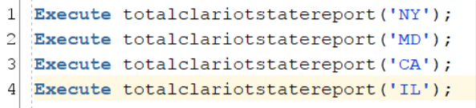

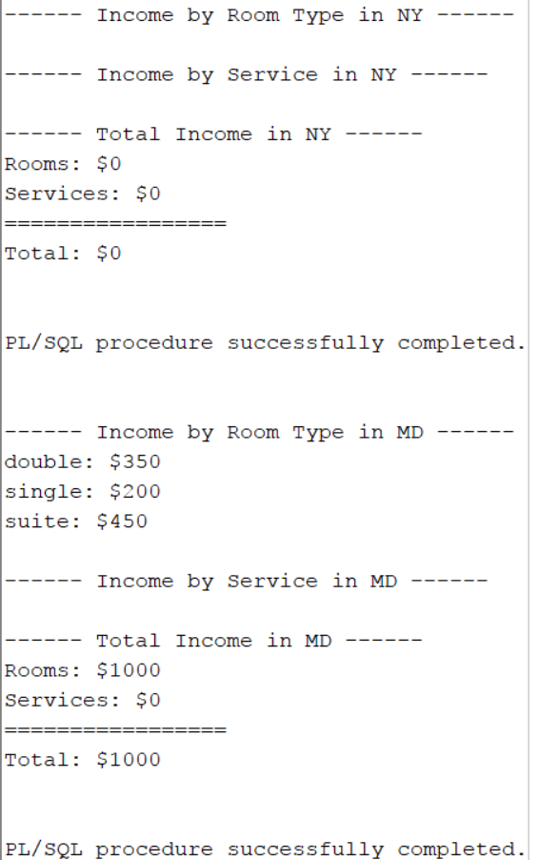

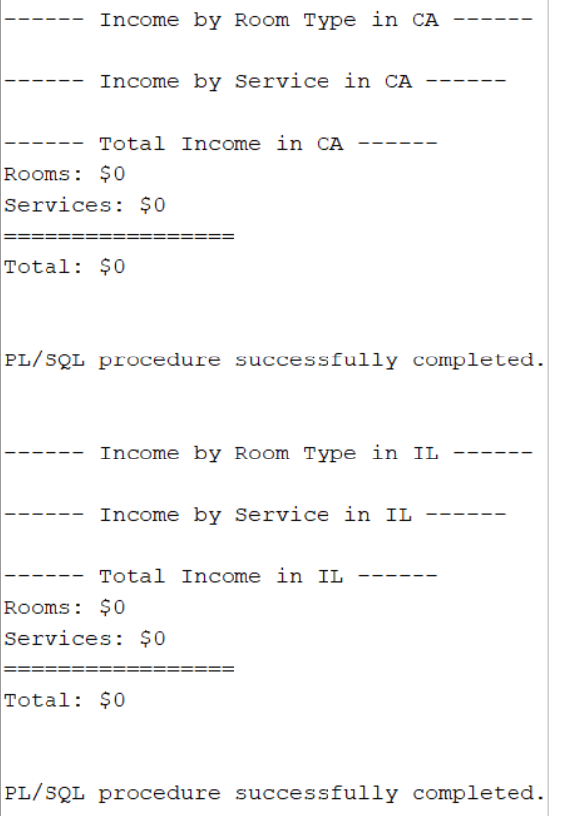

26. Change one reservation date and make it much earlier so that discounts will not apply for

that reservation Josiah

CHANGERESERVATION(2,to_date('07-21-17','MM-DD-YY'),to_date('07-26-17','MM-DD-YY'));

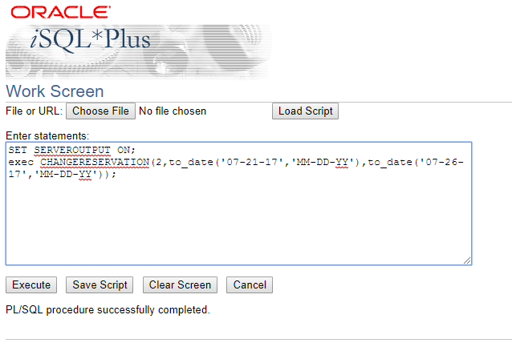

27. Total Clariot State report for NY, MD, CA, IL Added by Grayson

Execute totalclariotstatereport('NY');

Execute totalclariotstatereport('MD');

Execute totalclariotstatereport('CA');

Execute totalclariotstatereport('IL');



